**Bootstrap a centos node**

##### **Step 1: Note your Internal DNS name and pem key of your Node**

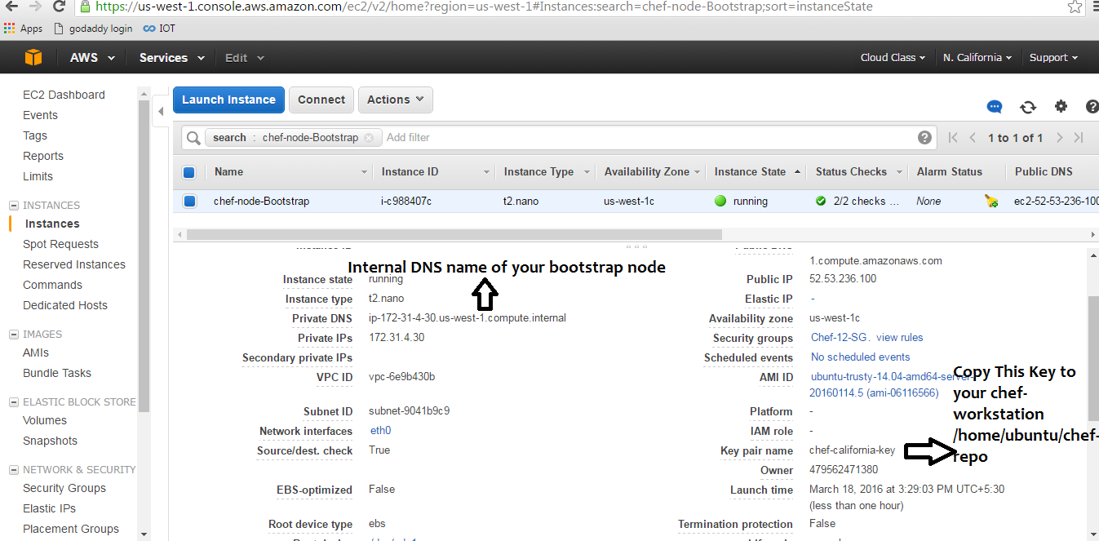

##### **Step 2 : Copy your pem file of Node which you intend to bootstrap**

Note : This should be copied on your chef-workstation

cp /home/ubuntu/chep.pem /home/ubuntu/chef-repo/chef.pem

**Step 3 : Change permission to your pem file**

# chmod 400 chef.pem

**Step 4 :Bootstrap your first chefrhel node**

knife bootstrap 52.67.175.21 -N rhel-node01 --ssh-user ec2-user --sudo --identity-file chef.pem

**Step 5 :validate on dashboard**

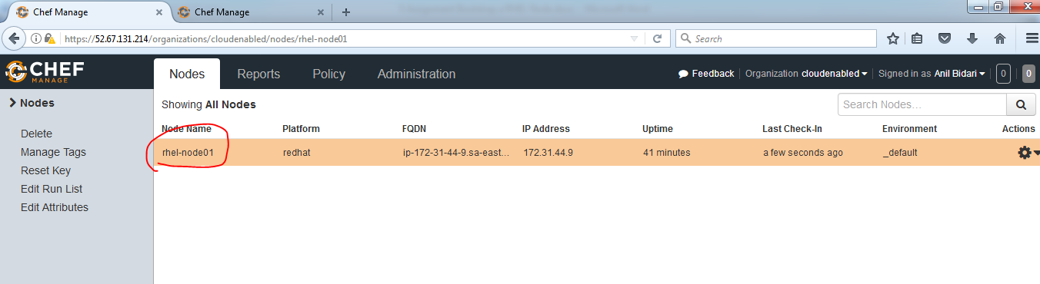

**Step 6:Add httpd run list to the node**

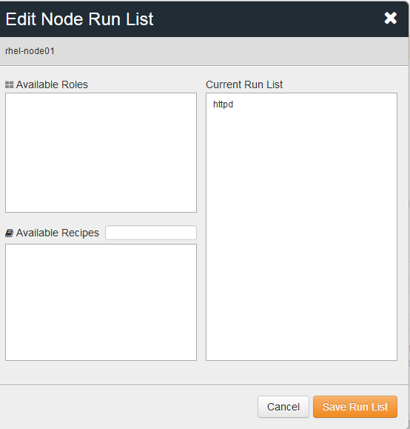

**Step 7 :**Apply the run list from UI and run chef-client on Ubuntu server

Knife ssh "*:*" -x ec2-user --identity-file chef.pem "sudo chef-client"

Validate on web browser if your web server is is up and index.html is available

You should see that is not serving

